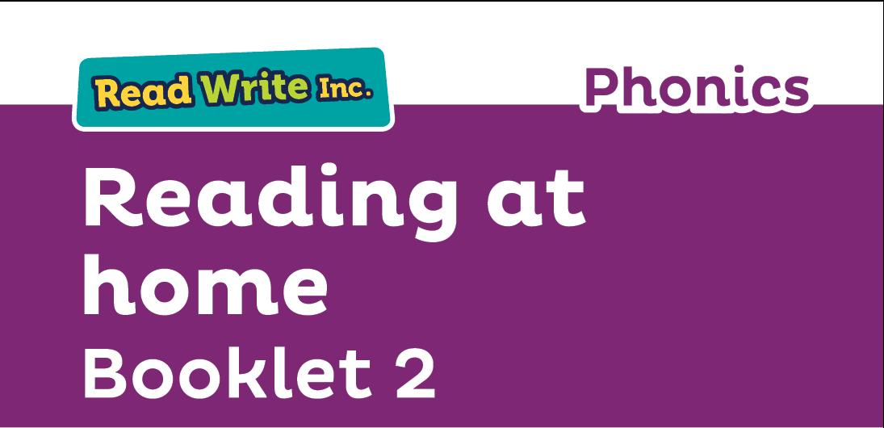

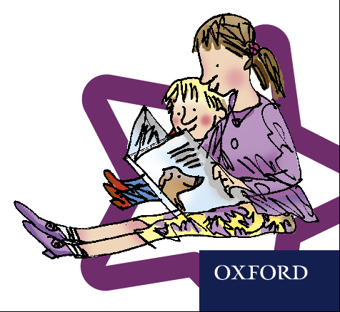

Your child is learning to read with ***Read Write Inc. Phonics***, a very popular and successful literacy programme. This **second booklet** shows you how you can get your child off to a quick start.

Your child will learn to read in a very simple way.   
He or she will learn to:

1. Read letters by their sounds

2. Blend these sounds into words

3. Read the words in a story

**How will my child learn to read?**

Your child will have already learnt to read:

* Set 1 Speed Sounds. These are sounds written with one letter:

**m a s d t I n p g o c k u b f e l h r j v y w z x**

and sounds written with two letters (your child will call these ‘special friends’)

**sh th ch qu ng nk ck**

* Words containing these sounds, by sound-blending e.g. *m-a-t* mat, *c-a-t* cat, *g-o-t* got,   
  *f-i-sh* fish, *s-p-o-t* spot, *b-e-s-t* best, *s-p-l-a-sh* splash
* Blending books and Red, Green and Purple storybooks.

Now, he or she will learn to read:

* Set 2 speed sounds: **ay, ee, igh, ow oo oo ar or air ir ou oy**
* Words containing these sounds
* Pink, Orange and Yellow storybooks.

Now, he or she will learn to read:

* Set 3 speed sounds: **ea, oi, a-e, i-e, o-e, u-e, aw, are, ur, er, ow, ai, oa, ew, ire, ear, ure**
* Words containing these sounds
* Blue and Grey storybooks.

**How to listen to your child read**

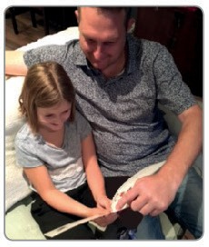 

* Do not read the book aloud before your child reads it to you
* Ask your child to read the sounds and words before he or she reads the story
* When the child reads the story, ask him or her to sound out the words that he or she can’t read automatically. Don’t allow your child to struggle too much. Praise your child when he or she succeeds.
* Read back each sentence or page to keep the plot moving.
* Do not ask your child to guess the word by using the pictures.
* Do it all with patience and love!

We have a storytime every day at school so children develop a love of stories. We hope that you will do the same by reading a bedtime story to your child every night. We have wonderful books in school for you to borrow.

**What will your child bring home?**

**A paper book**: this is a copy of the book he or she will have read in school three times with their reading teacher. They should be able to read this story confidently. A brief explanation of how to follow the activities is included in the books.

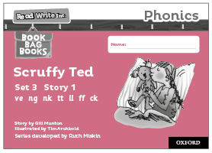

**A ‘book-bag’ book:** this book builds upon the ideas and many of the words in the storybook he or she has already read. Your child will need more support in reading this book. Again, explanations of how to use the activities are included. 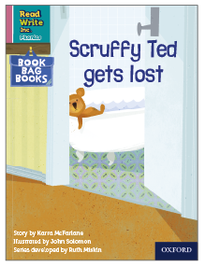



**Glossary**

* **Fred Talk** – sounding out the word before reading (blending)
* **sound-blending** – putting sounds together to make a word, e.g. c–a–t *cat*
* **special friends** – sounds written with more than one letter, e.g. **sh**, **ng**, **qu**, **ch**
* **Speed Sounds** – the individual sounds that make up words