Your child is learning to read with ***Read Write Inc. Phonics***, a very popular and successful literacy programme. This **first booklet** shows you how you can get your child off to a quick start.

Your child will learn to read in a very simple way.   
He or she will learn to:

1. Read letters by their sounds

2. Blend these sounds into words

3. Read the words in a story

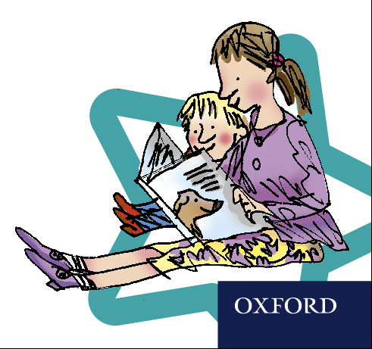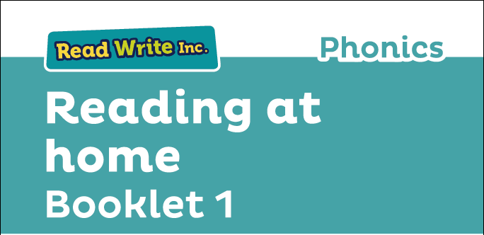

**How will my child learn to read?**

First, your child will learn to read:

* Set 1 Speed Sounds. These are sounds written with one letter:

**m a s d t I n p g o c k u b f e l h r j v y w z x**

and sounds written with two letters (your child will call these ‘special friends’)

**sh th ch qu ng nk ck**

* Words containing these sounds, by sound-blending e.g. *m-a-t* mat, *c-a-t* cat, *g-o-t* got,   
  *f-i-sh* fish, *s-p-o-t* spot, *b-e-s-t* best, *s-p-l-a-sh* splash
* Blending books and Red, Green and Purple storybooks.

Second, he or she will learn to read:

* Set 2 speed sounds: **ay, ee, igh, ow oo oo ar or air ir ou oy**
* Words containing these sounds
* Pink, Orange and Yellow storybooks.

Third, he or she will learn to read:

* Set 3 speed sounds: **ea, oi, a-e, i-e, o-e, u-e, aw, are, ur, er, ow, ai, oa, ew, ire, ear, ure**
* Words containing these sounds
* Blue and Grey storybooks.

**How to listen to your child read**

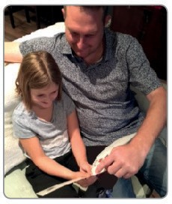 

* Do not read the book aloud before your child reads it to you
* Ask your child to read the sounds and words before he or she reads the story
* When the child reads the story, ask him or her to sound out the words that he or she can’t read automatically. Don’t allow your child to struggle too much. Praise your child when he or she succeeds.
* Read back each sentence or page to keep the plot moving.
* Do not ask your child to guess the word by using the pictures.
* Do it all with patience and love!

We have a storytime every day at school so children develop a love of stories. We hope that you will do the same by reading a bedtime story to your child every night. We have wonderful books in school for you to borrow.

**What will your child bring home?**

**A sound blending book**: ask your child to read each word in sounds (Fred Talk) and then say the word. Then he or she, can turn over and see if they’re right.

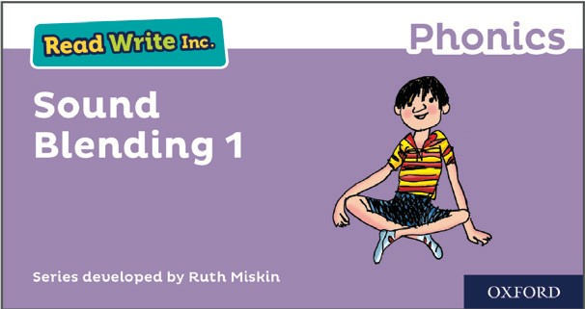

**A paper book:** as soon as your child starts to read the storybooks, they will bring a paper copy of the book he or she has been reading in school with their reading teacher. They will have read this three times so should be able to read confidently. A brief explanation of how to follow the activities is included in the books.

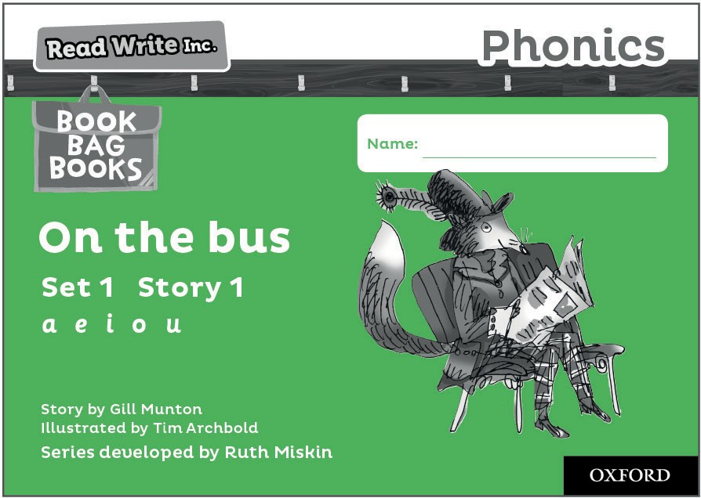 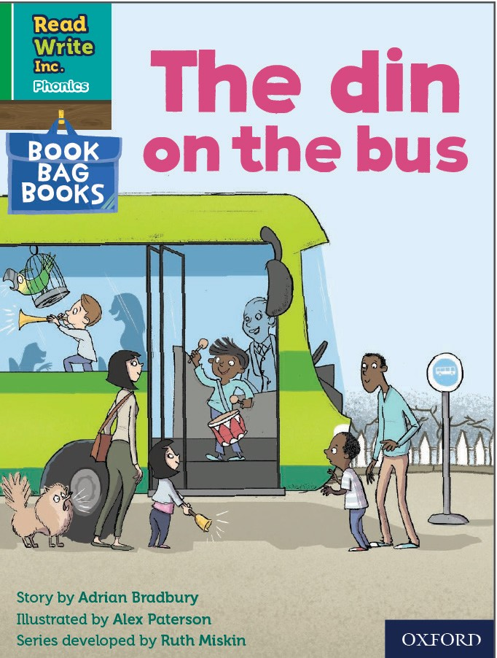

**A ‘book-bag’ book:** this book builds upon the ideas and many of the words in the storybook he or she has already read. Your child will need more support in reading this book. Again, explanations of how to use the activities are included.

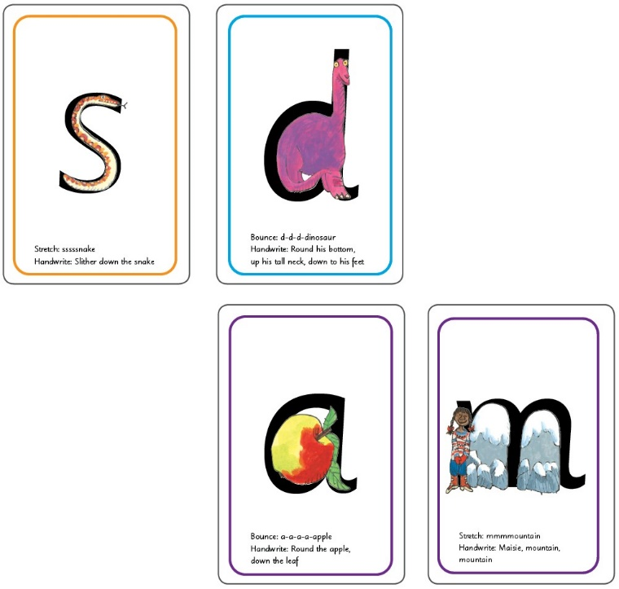

* ‘s’ in the shape of a snake
* ‘d’ is in the shape of a dinosaur
* ‘a’ is in the shape of an apple
* ‘m’ in in the shape of two mountains

**Help your child read the Set 1 speed sounds**

Before you get going, visit [www.ruthmiskin.com/parents](http://www.ruthmiskin.com/parents) to practice saying the sounds. The more clearly ***you*** say the sounds, the more quickly your child will learn them.

Your child will bring home the Set 1 Speed Sound cards. You’ll see that each sound is drawn in the shape of a picture. For example:

**Important:** we say ‘mmm’ not ‘muh’ and ‘lll’ not ‘luh’ when teaching the sounds. This really helps the children when they learn to blend sounds together to read words.

**Using the Set 1 speed sound cards**

The name of each picture is written on the back of the cards.

1. Ask your child to say the name of the picture on the back of each card e.g. a-a-a-apple, sssssnake getting quicker each time.
2. Help your child to say the sound hidden behind each picture e.g. ‘s’ is behind the snake.
3. Help your child to say the sounds on the letter side, getting quicker each time. If he or she forgets, turn back to the picture side. When your child can say the sounds without turning over to check, increase the speed!



**Help your child to read words**

Once your child can read Set 1 speed sounds confidently, he or she can learn to read words. First, your child is introduced to a toy frog called Fred. Fred can only say the sounds in a word and needs your child to help him read the word. So, when you hear your child say ‘Fred Talk’, you’ll know this means sounding out the word.

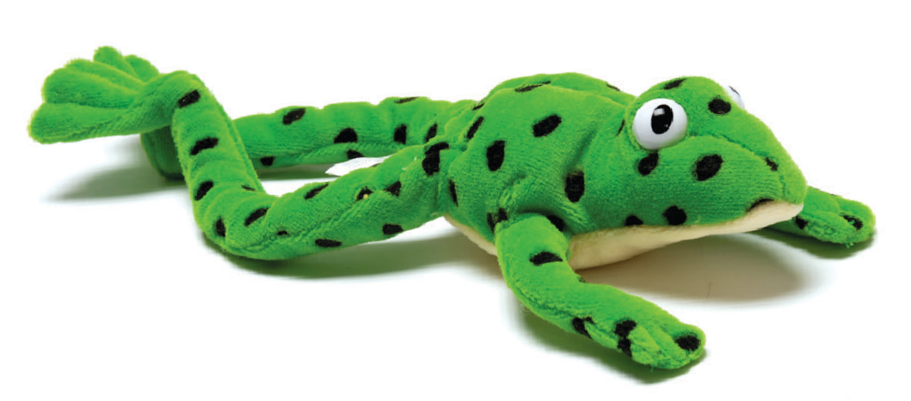

You can help your child by following these steps:

1. Make up a word with 3 cards that your child can read quickly e.g. c-a-t

 

Point to and say the sounds, and then say the word. Ask your child to copy you. Muddle up the cards. Ask your child to make the word again, and then point to and say the sounds. Repeat with more 3-sound words, including some containing sounds made up of more than one letter, e.g. ch–a–t, sh–i–p, th–i–s.



* **Fred Talk** – sounding out the word before reading (blending)
* **sound-blending** – putting sounds together to make a word, e.g. c–a–t *cat*
* **special friends** – sounds written with more than one letter, e.g. **sh**, **ng**, **qu**, **ch**
* **Speed Sounds** – the individual sounds that make up words

2. Put out three cards. This time, ask your *child* to say the sounds. Help him or her to blend the sounds into the words, until your child can do it without your help.

3. Repeat with some 4-sound words, e.g. b–l–i–p, f–r–o–g, g–r–i–n, s–t–o–p, j–u–m–p, h–a–n–d, b–l–a–ck.

**Glossary**