‘Feel good’ Friday!
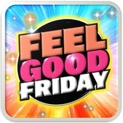
We are aware of the demands of home schooling and the mental health of everyone so…to add a little spice and to have an exciting end to the week, we are introducing:
‘Feel Good’ Fridays…
starting on the 12th February!
By then, your child will have received a sticker booklet packed with lots of fun activities to do over the coming weeks along with a pack of stickers to pop on each activity when it has been completed!
Those children in school will be taking part in their bubbles!
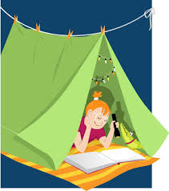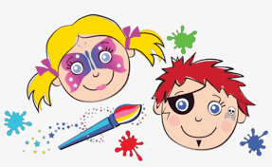
We know you are creative so you may even choose to do your own screen free/ feel good activities.
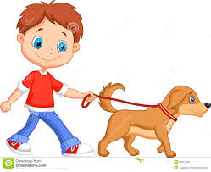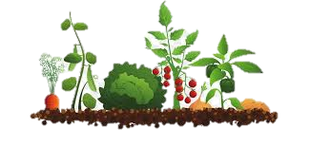
All we ask, is that you share some pictures or video clips on Google Classroom or Tapestry of what you get up to!
Keep an eye out each week to see what the teachers have been up to too!

