

**Remote Learning**

To all parents and children of Rivacre Valley Primary School, we wanted to send a message to say well done and thank you!

You have all worked *incredibly* hard since the news hit regarding partial school closures. We understand that some days will be easier than others and offer our full support throughout. We also recognise the challenges and would like to share with you some exciting news which may help on those more challenging days.



From **Monday 11th January**, lessons and programmes will broadcast on TV on CBBC between 9 and 12pm each day.

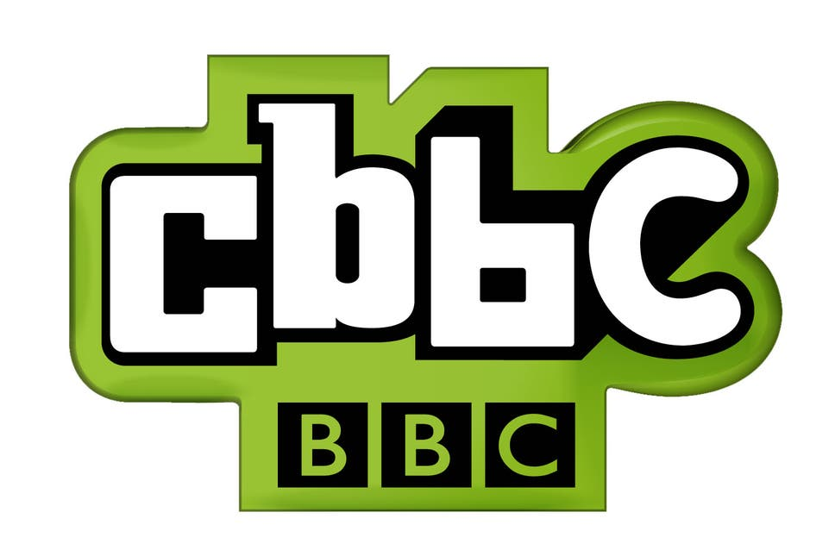

If all else fails, take a break and switch on the TV! All of the lessons will be available to access at any time on the BBC I-player too. Your child’s class teacher will post the week’s schedule on your Google Classroom stream and it will be on our school website each week too so keep your eyes peeled!