Rivacre Valley Primary School: January 2021

Welcome to Rivacre Valley Primary School.
As we enter into another period of lock down we thought it would be useful to update parents and carers on the arrangements in place.

The Government have said that all children should stay at home and schools will move to online learning.
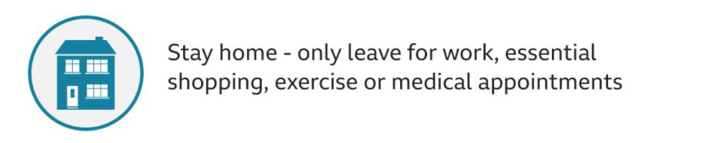
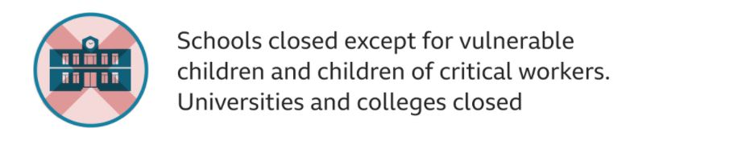
We believe the safest place for all children and adults is currently at home.
Please only access a school place if you have no alternative child care provision.

Key Information for January 2021:
Online learning:
All learning will be online. Engagement / participation with online learning is a requirement. It is not optional. School will contact you if your child does not log on and complete the online learning provided.

Children will be expected to wear their school jumper / cardigan so they can make the mental switch to school work and not being at home.
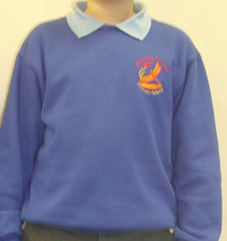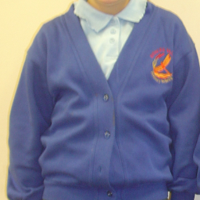
An example of a daily timetable for online learning:
Times | Morning activities
9:30am | Log onto Tapestry / Google classroom
9:45am | English
10:30am | Phonics
11:00am | Morning break
11:15am | Maths
12:00pm | Lunchtime
1:30pm | PE
2:00pm | Topic / music / My Happy Mind
2:30pm | Story time
3:00pm | Hometime!
A more detailed timetable will be provided for each phase / stage of school.

If you do not have access to a device please contact school at admin@rivacrevalley.cheshire.sch.uk and we will arrange the loan of a school device.

If you are entitled to Free School Meals for your child please contact the school office so that we can ensure a meal is provided on a daily / weekly basis.

More detail to follow on how this will be managed over the next few weeks but currently we are offering a drive up option at specific times to collect a lunch for your child:
EYFS | KS1 | LKS2 | UKS2
11:45am – 12:00pm | 12:00pm – 12:15pm | 12:15pm – 12:30pm | 12:30pm – 12:45pm
Provision for vulnerable children and children of critical workers:
If you can source alternative child care please only take up this offer as a last resort – staying at home is the safest place for your child and our staff.

Drop off | Collection | Location
9:00am | 3:00pm | Rivacre Brow entrance
At this present time no parents are permitted on site.
Any key information that needs to be shared please email / telephone the school office:
Tel: 0151 832 7602 email:admin@rivacrevalley.cheshire.sch.uk

Children will be expected to wear school uniform.

We will continue to make sure school is safe by doing the following:
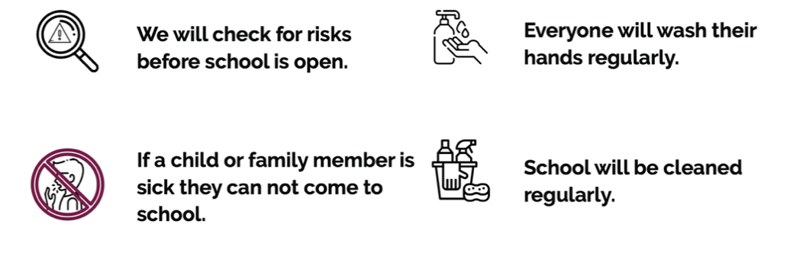

Your child will need to limit the amount of things they bring into school.
They will need:
A coat | A water bottle | 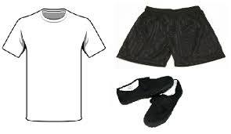  Their PE kit
Their reading book, reading record and bag | Hand cream / sanitiser (if you wish) | 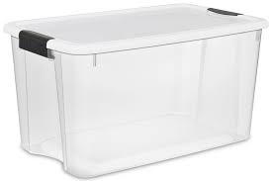  All of their belongings will be stored in their plastic box

Your child will also have their own set of resources to use throughout the day to help them with their learning.

Lunchtime:
Everyone will eat lunch in their classroom. This will help keep everyone safe in their class bubble.

Lunches will be provided by the catering team as usual or you can provide your child with a healthy packed lunch.

If your child is entitled to Free School Meals these will be provided by the catering team, alternatively you can purchase a meal for your child.

Social distancing in school:
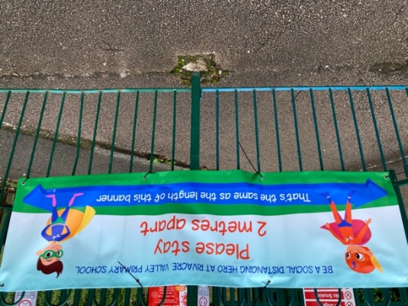

We will continue to encourage all children to maintain 2m social distance from staff.

Symptoms:
If anyone becomes unwell with a new, continuous cough, high temperature or loss or change of your sense of smell and taste, in an education or childcare setting, they must be sent home.
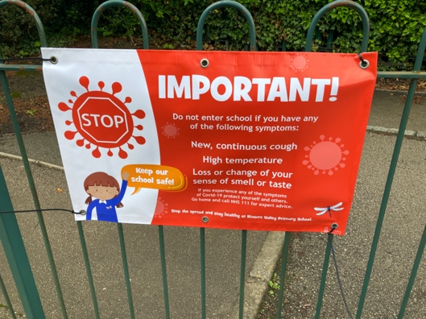

What if there is a case of Coronavirus in school?
10 days

The person with symptoms / positive test must self isolate for 10 days

10 days

The people they live with must self isolate for 10 days

10 days

If anyone at school tests positive, the whole class / bubble must self isolate for 10 days

Wrap around care (before and after school care):
At present we are unable to offer before and after school clubs as we do not want to mix / burst key worker / vulnerable children bubbles.
We apologise for this inconvenience.
As soon as we are able to offer this again we will let you know.

As we begin to get used to our new “normal” things may need to change but hopefully the above will help you prepare your child for the latest lockdown in Janaury 2021.
These continue to be challenging times, with much stress and anxiety, but we will ensure our best endeavours in moving forward safely for all.

If you would like to discuss any aspect of the above information please contact school.

Take care and stay safe,
Mrs Kate Docherty Mrs Kate Hubbard
Headteacher Chair of Governing Board

