Rivacre Valley Primary School

Learning offer during COVID-19 Pandemic
School open as normal | Children required to attend as normal  Children provided with a rich, broad and balanced curriculum offer – covering all subjects of the National Curriculum / Early Years Foundation Stage  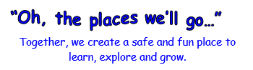  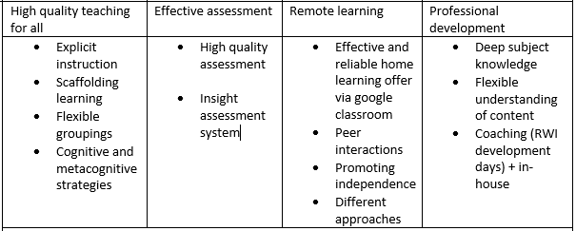  Catch up interventions / strategies:  Read, Write Inc.: EYFS / KS1 / LKS2  Read, Write, Inc.: Fresh Start – identified children in UKS2  Beanstalk reading  Wellcomm (S&L) – EYFS  Nuffield Early Language Intervention (NELI): Reception  Catch up to Y6 – UKS2  Narrative immersion & Helicopter stories: EYFS  My Happy Mind  Number blocks – EYFS / KS1  Maths interventions: Plus 1, Power of 2  NRich  White Rose Maths  In house Speech and Language teacher  Additional staff to boost / tutor  PPA covered by qualified teacher or grade 7 specialist TA  ELSA  DHT & AHT non class based  Mental health practitioner in school | Homework:  EYFS = Tapestry:  Homework activity grid  phonics  RWInc story books when ready  KS1:  Google classroom:  Homework activity grid  RWI story books  Phonics  Reading for pleasure book  KS2:  Google classroom:  Homework activity grid  RWI story books if applicable  Reading books  Timestables
Individual child self-isolating | Children will access learning virtually for the period of self-isolation  (If child is unwell there will be no expectation to complete home learning)  Class teacher will upload work onto virtual platform (Tapestry: EYFS / Google classroom: KS1 & 2)  - Daily phonics (EYFS / KS1)  - Daily English activity  - Daily maths activity  - Daily story time  - Daily PE activity  - Weekly My Happy Mind activity  - Weekly topic activity  - Weekly music activity  Teachers will also provide links to the following online materials:  Oak Academy/Bitesize/RWI sessions that will replicate/mirror lessons in school  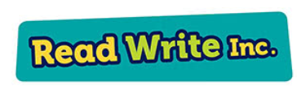  Teachers will check in with the child at the start and end of the day – via virtual platform stream to check they understand what they have to do. If they do not respond a member of Admin staff / Class TA will contact via telephone to check they are able to access. | Any child who does not have access to a device will be provided with a school ipad for the duration of the self-isolation or paper resources (if preferred by parent)
Whole bubble self-isolating | Children will access learning virtually for the period of self-isolation  (If child is unwell there will be no expectation to complete home learning)  Class teacher will log onto virtual platform (Tapestry: EYFS / Google classroom: KS1 & 2) – children expected to sign on by 9:30. If no activity is visible a member of school staff will telephone to check if they are okay and able to access. They will also remind the child that this is not optional.  Work for the day / week will be uploaded. Children can complete in any order.  - Daily phonics (EYFS / KS1)  - Daily English activity (use Literacy Company home learning resources alongside the online materials used for individual child self-isolating)  - Daily maths activity  - Daily story time  - Daily PE activity  - Weekly My Happy Mind activity  - Weekly topic activity  - Weekly music activity  Class teacher will check back in with class at 12:00pm – to see how the mornings learning has gone and to go over any misconceptions.  Class teacher will check back in with class at 3:30pm – to see how the afternoons learning has gone and to go over any misconceptions.  Class stream will be monitored throughout and feedback provided to children. All work uploaded will be marked. | Any child who does not have access to a device will be provided with a school ipad for the duration of the self-isolation or paper resources (if preferred by parent)

