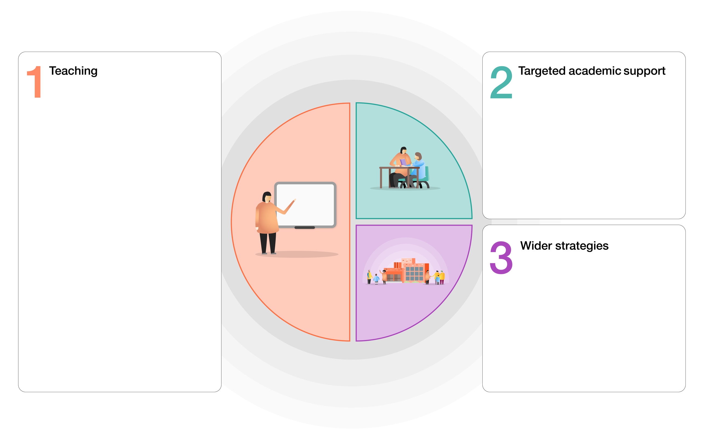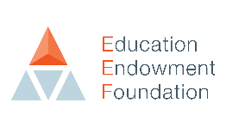

How we intend to use the COVID-19 Catch up Premium

High quality teaching for all children. Focus on:

* Explicit instruction
* Scaffolding learning
* Flexible groupings
* Cognitive and metacognitive strategies

Use coaching / mentoring to support staff development (SLT)

Assessment:

Effective high quality assessment which includes analysis of progress and attainment enabling teachers to focus teaching to plug gaps (Insighttracking.com): Each half term

Remote learning: (See learning offer plan)

* Effective and reliable home learning offer via google classroom / Tapestry
* Peer interactions – google stream
* Promoting independence
* Different approaches – use of Oak Academy / Bite size / RWI / Literacy Company
* Daily check to support engagement with learning and identify any difficulties / change in wellbeing

Professional Development:

* Deep subject knowledge (CPD)
* Flexible understanding of content – support with planning + use of text books & schemes
* Coaching (RWI development days) + in-house

Social, emotional and behavioural needs:

* Establishing routines
* MyHappyMind
* ELSA
* Mental Health Practitioner in school
* DHT and AHT non class based
* Our ways of working: Trauma informed practice

Parents – communication and support:

* Email links
* Zoom parent teacher meetings
* Tapestry / Earwig academic

Attendance – monitor daily (Studybugs)

**How the impact of this expenditure on educational attainment will be assessed:**

* Teacher assessment: gains in progress, skills and knowledge
* Formal summative assessment (RWInc / Phonics screen / SATs / benchmarking / EYFS profile)
* Parents and children know what the child can do and their next steps (Earwig Academic / tapestry / Google classroom)
* Pupil wellbeing questionnaires
* Happy children, attending school regularly.
* Behaviour in school continues to be outstanding: 0 exclusions

How we intend to use the COVID-19 Catch up Premium

0.4FTE teacher in UKS2 – boost reading and maths/ DHT – interventions for LKS2 / AHT: Step up to Year 6

Read, Write Inc.: EYFS / KS1 / LKS2

Read, Write, Inc.: Fresh Start – identified children in UKS2 / Beanstalk reading

Wellcomm (S&L) – EYFS

Nuffield Early Language Intervention (NELI): Reception

Narrative immersion & Helicopter stories: EYFS

Number blocks – EYFS / KS1

Maths interventions: Plus 1, Power of 2 / NRich

White Rose Maths

In house Speech and Language teacher

ELSA

Mental health practitioner in school

**EEF GUIDE TO SUPPORTING SCHOOL PLANNING (2020-21) – TIERED MODEL**

Rivacre Valley Primary School: COVID-19 Recovery Curriculum and Catch up premium