**Rivacre Valley Primary School**

MCj03264780000[1]

**“Oh the places we’ll go…”**

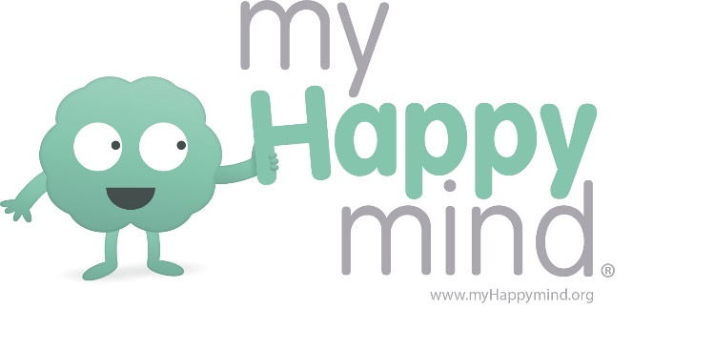

Dear Parents,

We have introduced a program to all year groups at school called myHappymind.

myHappymind is all based around helping children to understand how their brain works and to support them in developing positive skills and habits to be their very best selves and support their Mental Health and Wellbing.

myHappymind is delivered in schools by class teachers through a series of interactive lessons and then the children apply these learnings throughout the day. The children will have myHappymind sessions each week.

To further embed this learning and ensure that you are able to engage in these topics with your child, myHappymind has developed a free App for parents.

The myHappymind App for Parents is available on both Google Play and on the Apple store. The App allows children to continue to practice some of the habits they have developed at school e.g. happy breathing and for you to learn more about the program too.

To access the App just go to myhappymind.org/parents and you’ll be guided through the process. We really encourage you to make use of this free App so that you can support your child in getting the best out of the curriculum.

If you have any questions about the curriculum, please contact your class teacher. If you have any technical questions about the app, please contact [hello@myHappymind.org](mailto:hello@myHappymind.org)

Kind regards,

Mrs K Docherty