Rivacre Valley Primary School: September 2020
Welcome to Rivacre Valley Primary School – we are really looking forward to seeing you again or meeting you for the first time.

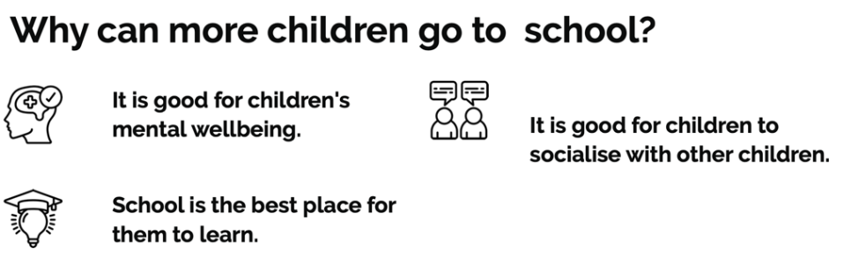
The Government have also now said it is safe for all children to return to school
Key Information for September:
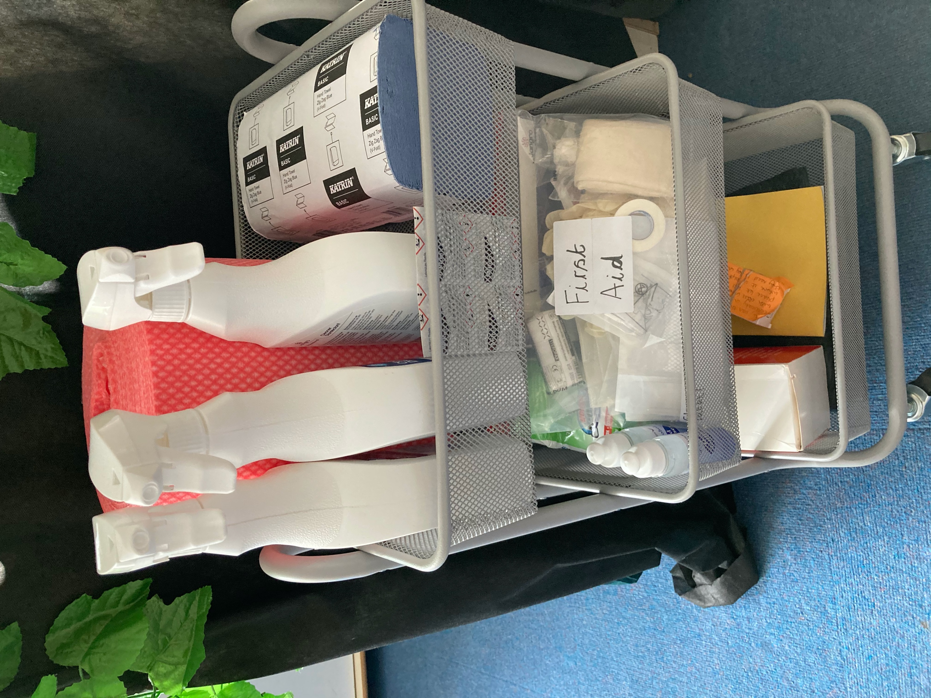
Cleaning stations in every room
We will make sure school is safe by doing the following:
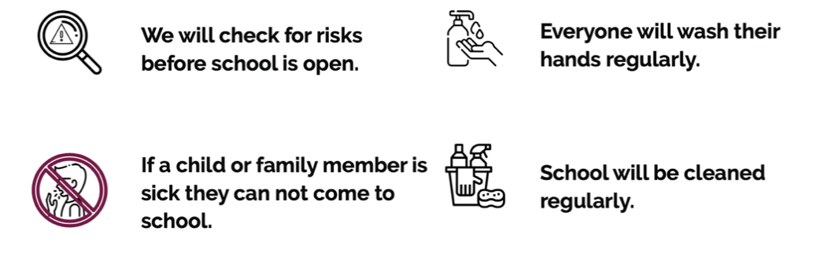
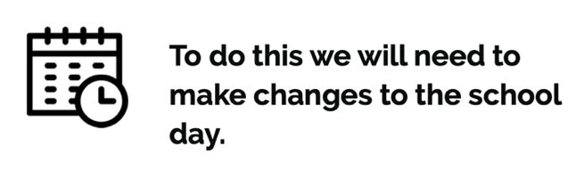
Drop off / collection times:
Year group | Drop off time | Collection time | Location
Year 5 & 6 | 8:30am | 3:30pm | Warren drive – each year group to have allocated side of railings to drop off / collect from
Year 3 & 4 | 8:40am | 3:20pm
Year 1 & 2 | 8:50am | 3:10pm
Reception | 8:50am | 3:10pm | Rivacre Brow entrance – walk up path and drop off outside Nursery / Reception gates
Nursery | 9:00am | 3:00pm | Rivacre Brow entrance – walk up path and drop off outside Nursery / Reception gates
If you have children in more than 1 year group please drop off at the latest time and pick up at the earliest time., EG. If you have a child in Y4 and another in Y1, please drop both children off at 8:50am and pick up at 3:10pm.

An area will be marked on the path – please keep this area clear.
Please try and walk / cycle to school, as that will help reduce the amount of congestion at our drop off and collection points.
At this present time no parents from KS1 and KS2 are permitted on site. Any key information that needs to be shared please email / telephone the school office:
Tel: 0151 3382020 email: admin@rivacrevalley.cheshire.sch.uk
We will keep children in class bubbles:

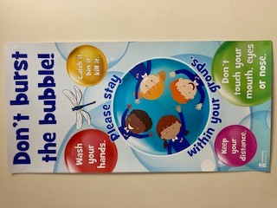
Miss Oughton Year 1 & 2
Miss Stokes Year 1 & 2
Mr Denham & Mrs Vaughan Reception
Miss Woods & Mr Davies Nursery
Mr McEnroe
Year 3 & 4

Miss Roberts Year 1 & 2

Miss Jones Year 5 & 6
Mr Parsonage
Year 3 & 4

Miss Causer Year 5 & 6
Mrs Morgan & Mrs Denham Year 3 & 4
Miss Gidlow Year 5 & 6

Your child will need to limit the amount of things they bring into school.
They will need:

- A coat

- A water bottle 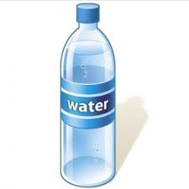

- Their PE kit 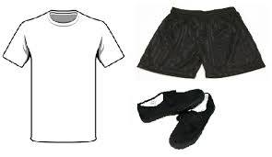

- Their reading book, reading record and bag 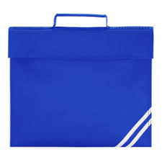

- Hand cream / sanitiser (if you wish)

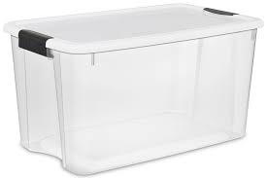All of their belongings will be stored in their plastic box which will either be kept; at the side of their desk (KS1 & 2) or in the cloakroom & outside area (EYFS)

Your child will also have their own set of resources to use throughout the day to help them with their learning.
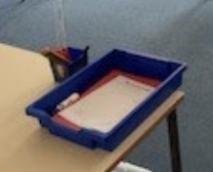
The classrooms may look a little different
EYFS: Reception and Nursery may look like this
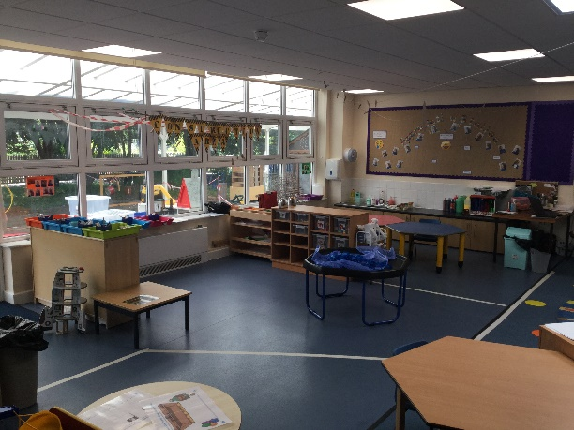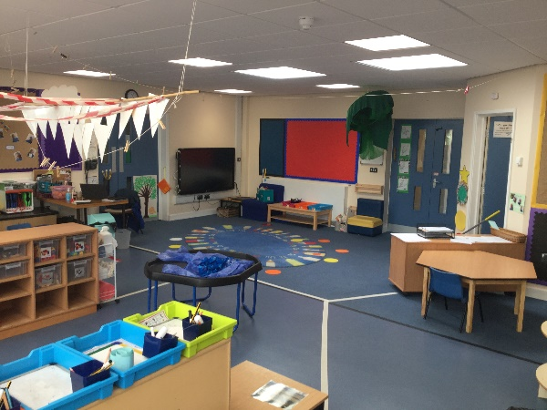

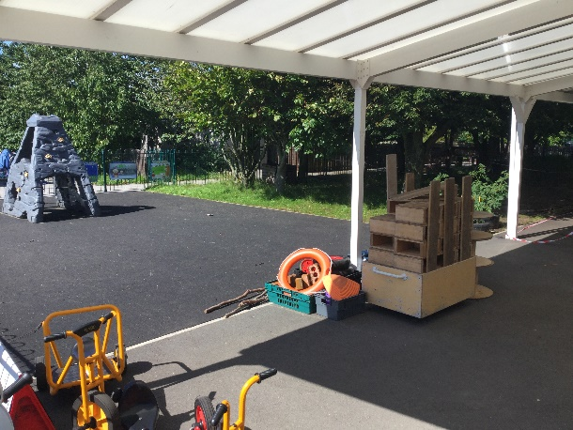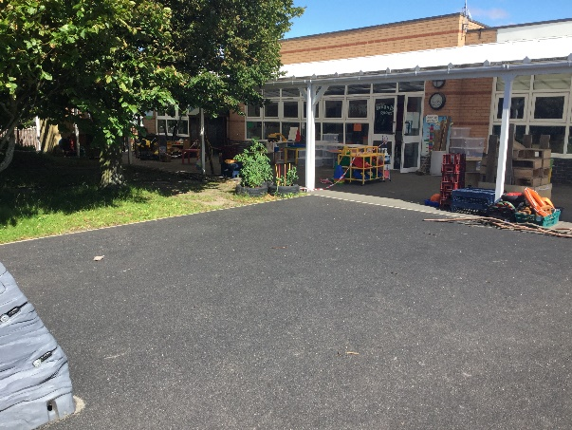

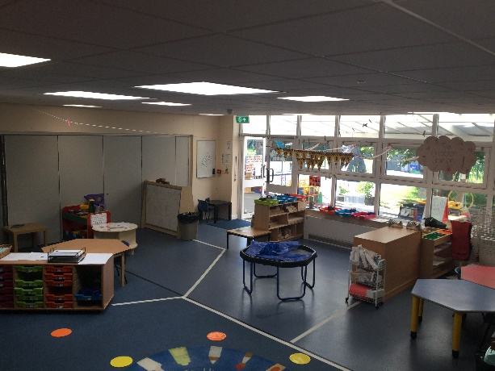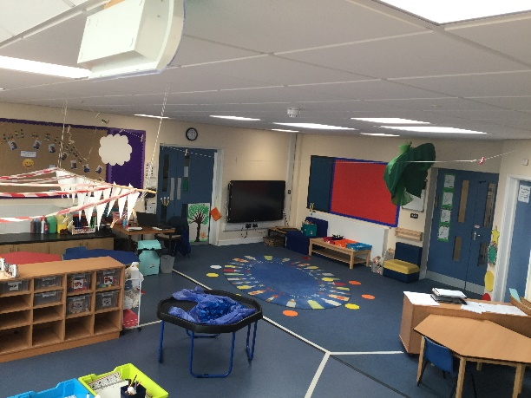

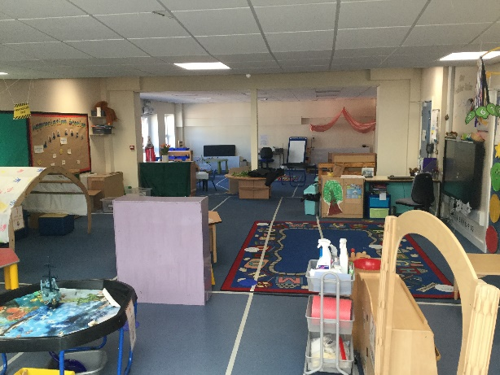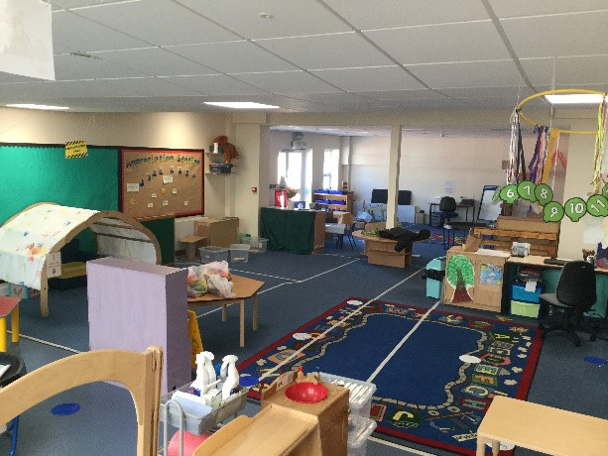

KS1 and 2 may look like this with tables and chairs arranged facing the front of the class:
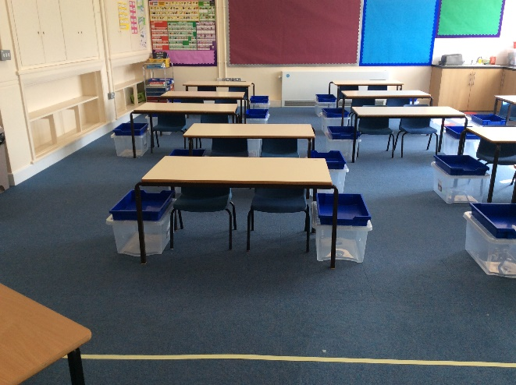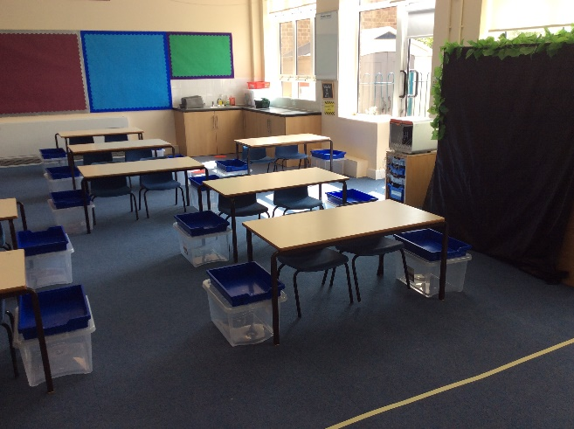
A line to help you stay 2m away from your teacher
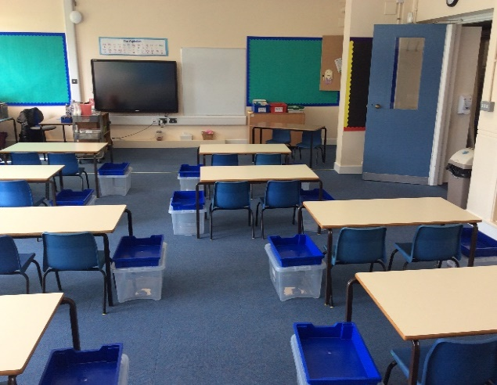
Space between the tables so we can safely move around the classroom
Your own plastic box for your belongings with a tray on top for your resources.
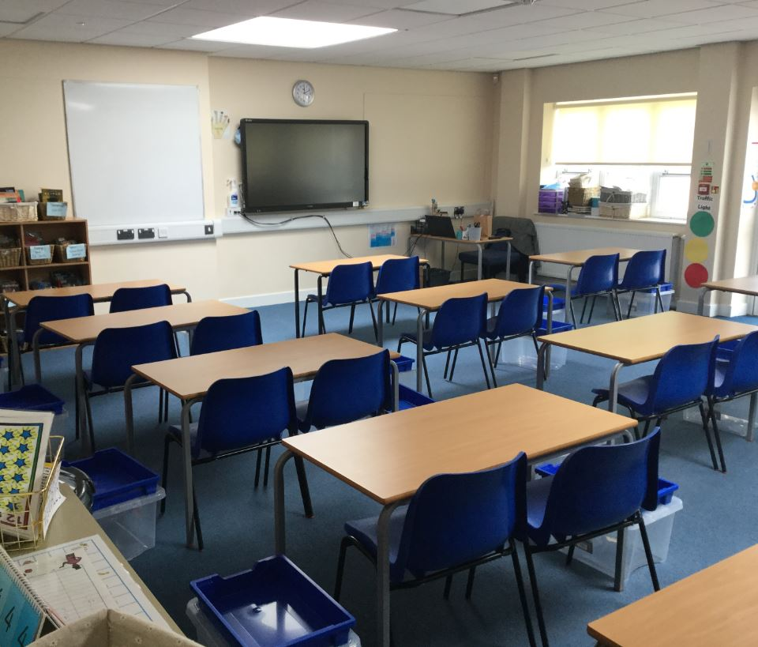

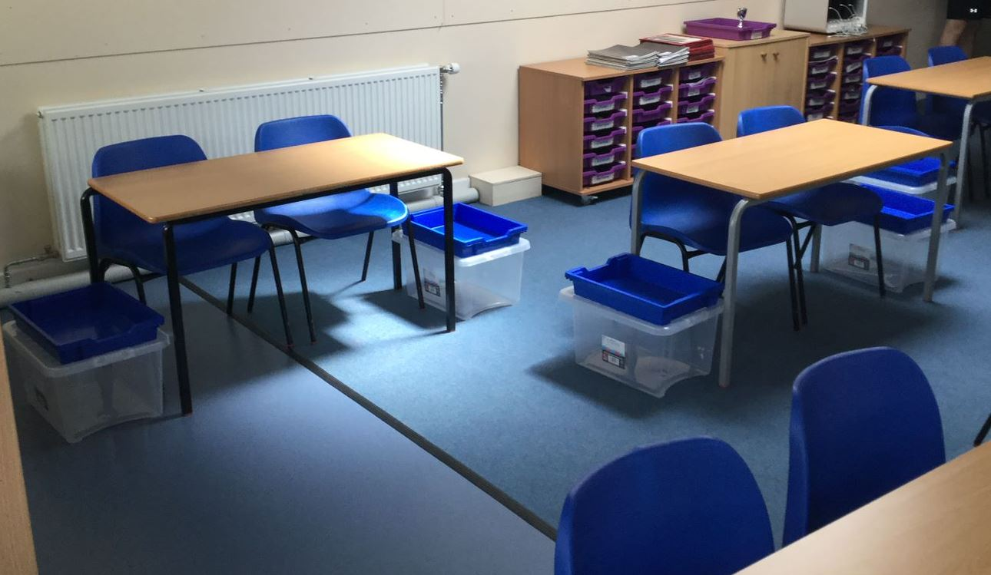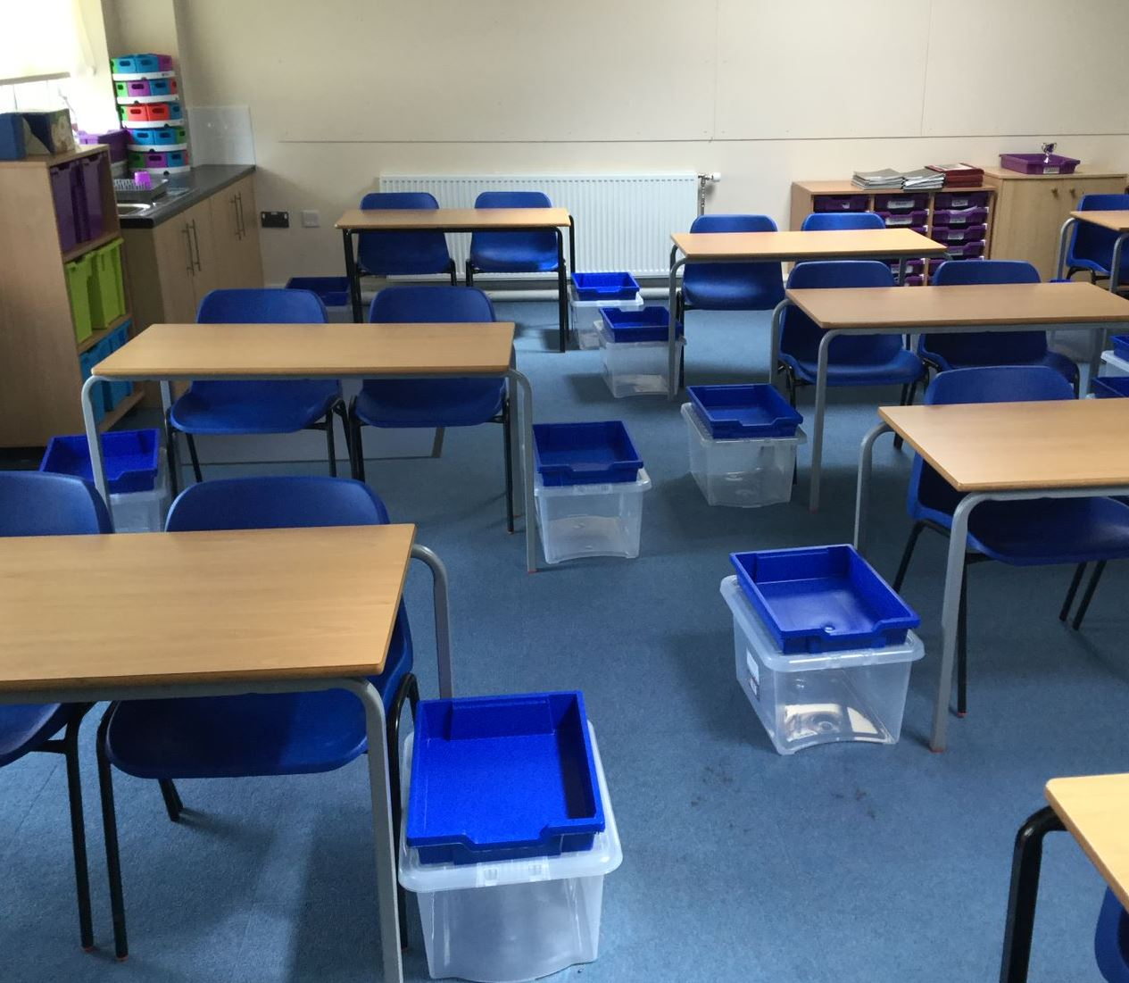

Lunchtime:
Everyone will eat lunch in their classroom. This will help keep everyone safe in their class bubble.
Lunches will be provided by the catering team as usual.
Children in Reception, Year 1 and Year 2 will receive a Universal Infant free School Meal (UIFSM)
Children in Nursery and KS2 can purchase a meal, or receive them for free if you qualify for a Free School Meal (FSM). Please enquire at the office to see if you are entitled to a FSM for your child.

Packed lunches:
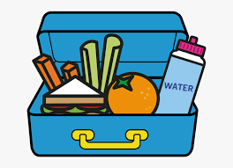
You can also provide your child with a healthy packed lunch – please remember to put a cool / ice pack inside to keep it fresh, as it will be stored in their plastic box.

A take home lunch will be provided on a Friday for children entitled to a FSM and UIFSM. You can also order a take home lunch for your child if you would like.

The DfE have confirmed the following:
- Primary pupils do not need to be kept apart in the classroom.
- Staff should keep 2m away from children at the front of the classroom
Staff will have a screen on their work desk so they can support children and still keep themselves safe.
No face masks will be worn

Social distancing in school:
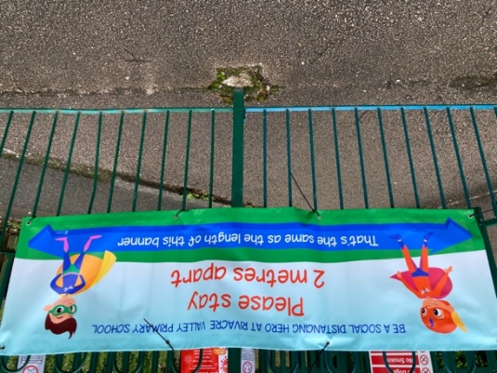

Symptoms:
If anyone becomes unwell with a new, continuous cough, high temperature or loss or change of your sense of smell and taste, in an education or childcare setting, they must be sent home.
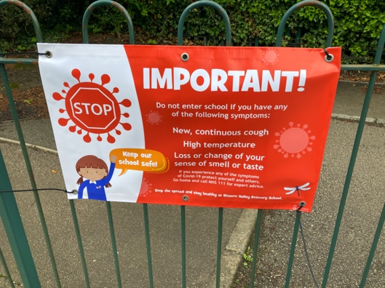

If your child has symptoms:
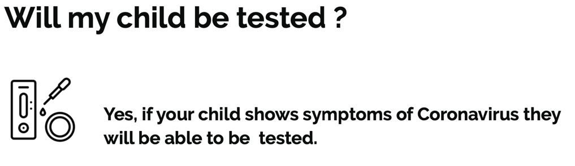
The Government will issue testing kits to school which we can distribute as required.

What if there is a case of Coronavirus in school?
10 days

The person with symptoms / positive test must self isolate for 10 days

14 days

The people they live with must self isolate for 14 days

14 days

If anyone at school tests positive, the whole class / bubble must self isolate for 14 days
Wrap around care (before and after school care):
At present we are unable to offer before and after school clubs as we do not want to mix / burst class bubbles. We apologise for this inconvenience.
As soon as we are able to offer this again we will let you know.

As we begin to get used to our new “normal” things may need to change but hopefully the above will help you prepare your child for September. We hope you will agree that we have made the right decisions at the right time based on the evidence we have been given. These continue to be challenging times, with much stress and anxiety, but we will ensure our best endeavours in moving forward safely for all.

If you would like to discuss any aspect of the above information please contact school.

Take care and stay safe,
Mrs Kate Docherty Mrs Kate Hubbard
Headteacher Chair of Governing Board

