
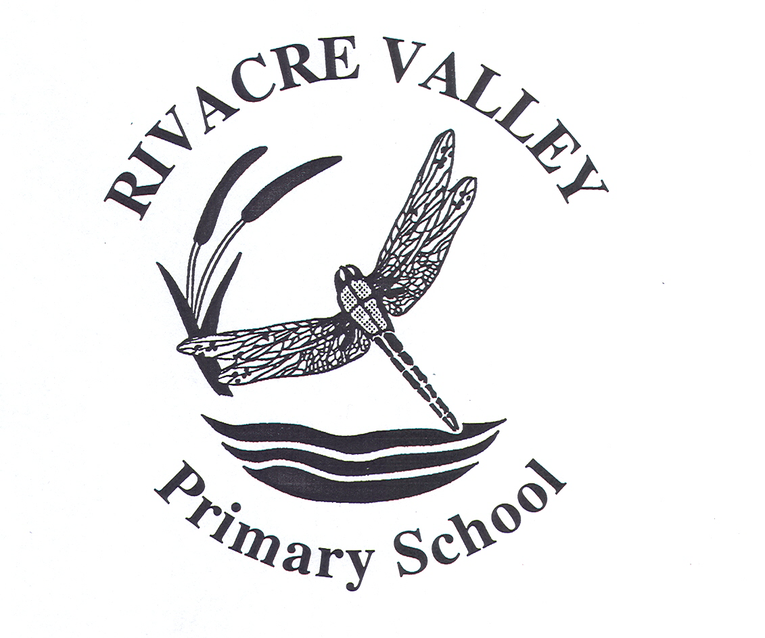
1st October 2021
Dear Parent / Carer
I am writing to inform you that our school participates in a Police-led initiative called Operation Encompass, a scheme which ensures that we can better support any child where a domestic incident has been reported to Police from their home.
Following a domestic incident, the Police make contact with the school via telephone and communicate relevant information to nominated, fully trained school staff. This ensures that we are made aware early enough to support children and young people in a way that means they feel safe, supported and listen to.
Each school has a member of staff called a key adult who is trained to liaise with the police, when required, whilst ensuring support is available to the child.
The initiative has already been trialled & is now live in our schools across the local authority areas of Halton, Warrington, Cheshire West & Chester and Cheshire East with success. You can find out more about Operation Encompass via the following site: http://www.operationencompass.org/

If you would like to speak to someone further about the initiative, or require any additional information, please do not hesitate to contact Mrs Docherty or Miss Hughes.
We are committed to working in partnership with local relevant organisations to safeguard and protect children across Cheshire and provide the best possible care and support for our pupils.
Yours faithfully,
Mrs K Docherty

Head teacher
Rivacre Valley Primary School

