A culinary tour around the United Kingdom
Week beginning 19th April.
Monday.
Full Irish cooked breakfast
‘Lucky’ chocolate penny
Tuesday.
Scottish ‘Bangers’ and mash.
Oat biscuit
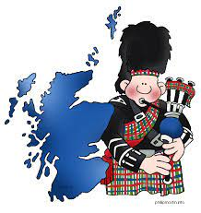
Wednesday.
‘Run rarebit Run’ burger. [Cheese and bacon.]
Welsh chocolate cake.
Thursday.
Traditional ‘English’ roast dinner.
‘Afternoon tea’ cakes and biscuits.
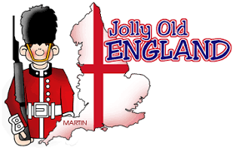
Friday.
St George’s day fish and chips!
‘Afternoon tea’ cakes and biscuits.
