**Dear parents / carers,**

We are really looking forward to being able to welcome back all children to Rivacre Valley Primary School on Monday 8th March 2021. Our focus for the first couple of weeks will be your child’s wellbeing and returning to our new “normal” for our curriculum offer.

**Please find below the key information you will need to prepare your child:**

Children will return to the classes they were in during the autumn term.

They will remain in these class bubbles throughout the day and will not

mix with any other class bubbles.

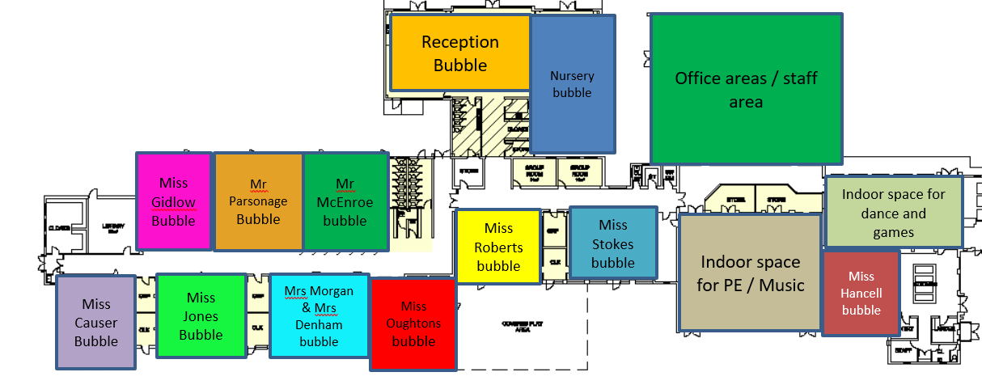

**We will make sure school is safe by doing the following:**

**What are the times of the school day and where do I bring my child into school?**

In order to limit congestion and to adhere to DfE guidance we will operate staggered drop off and collection times.

|  |  |  |  |
| --- | --- | --- | --- |
| Year group | Drop off time | Collection time | Location |
| Early Years Foundation Stage:  Nursery & Reception | 9:00am | 3:00pm  If your Nursery child is attending for ½ day - collection time will be at 12:00pm from the Main Reception gates (as was in December) | **Warren Drive entrance gates**.  Members of staff and the Senior leadership Team will supervise the gates.  No parents are permitted onto the school site without a prior appointment |
| Key Stage 1:  Year 1 & 2 | 8:50am | 3:10pm |
| Lower Key Stage 2:  Year 3 & 4 | 8:40am | 3:20pm |
| Upper Key Stage 2:  Year 5 & 6 | 8:30am | 3:30pm |

If you have siblings in several year groups please drop off your child at the latest time (i.e. the time for your youngest child) and collect at the earliest time (i.e. the time for your youngest child).

**Drop off and collection on Warren Drive:**

Please arrive promptly at the time allocated for dropping off and collecting your child. Once you have dropped off / collected your child please leave the area so other parents can drop off / collect their child.

If you choose to park please do so courteously.

Please do not park or stop on the yellow zig-zag lines, those are there to keep our children safe and the entrance area visible.

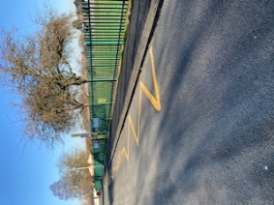

Please maintain 2m social distance when waiting by the railings – staff will endeavour to hand over your child to you as quickly as possible.

Please wear a face mask, unless you are exempt. 

Please do not enter the box directly outside the gate – this will enable staff to be able to receive and hand over children without coming into contact with other households.

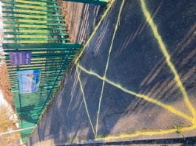

If you have a message for your child’s class teacher either pass it to the member of staff on the gate or contact the school office:

[admin@rivacrevalley.cheshire.sch.uk](mailto:admin@rivacrevalley.cheshire.sch.uk)

Telephone: 0151 8327602

**What can my child bring into school:**

**Your child will need to limit the amount of things they bring into school.**

They will need:

* A coat 
* A water bottle 
* Their PE kit A picture containing clothing, person, shirt, drawing

  Description automatically generated
* Their reading book, reading record and bag 
* Hand cream / sanitiser (if you wish) 

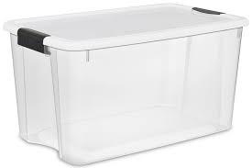All of their belongings will be stored in their plastic box which will either be kept; at the side of their desk (KS1 & 2) or in the cloakroom & outside area (EYFS)

Your child will also have their own set of resources to use throughout the day to help them with their learning.

**Lunches and food in school**



Everyone will eat lunch in their classroom. This will help keep everyone safe in their class bubble.

Lunches will be provided by Edsential catering team as usual.

Children in Reception, Year 1 and Year 2 will receive a Universal Infant free School Meal (UIFSM)

Children in Nursery and KS2 can purchase a meal, or receive them for free if you qualify for a Free School Meal (FSM). Please enquire at the office to see if you are entitled to a FSM for your child.

Packed lunches:

You can also provide your child with a healthy packed lunch – **please remember we are a *nut free* school.** You may also want to put a cool ice pack inside to keep it fresh, as it will be stored in their plastic box.



**A safe and clean environment**

Outside every classroom we have hand sanitiser dispensers – children will be encouraged to use these every time they enter the classroom. Children will also be encouraged to clean / wash their hands regularly throughout the school day and at specific times:

* when they arrive at school
* when they return from breaks
* when they return from another room / area of school
* before and after eating
* Also told to wash hands after coughing / sneezing / or have used a tissue

We have extended our cleaner hours to enable more frequent cleaning throughout the school day.

Each class / teaching space has a cleaning trolley and children will be encouraged to help keep their work spaces clean throughout the school day.

Doors will be kept open to avoid touching handles and where they can't be kept open (e.g. fire doors and toilets) more regular cleaning will take place.

By keeping children in fixed class groups, that don't mix, we will reduce risk of cross contamination. Shared equipment in subjects like Art, IT and Science will be cleaned before being returned to central storage. Classes will have their own play / sport & PE equipment for their class only.

I am sure you will understand that while cleaning regimes will be much enhanced, we can't guarantee every piece of equipment can be cleaned between children touching them.

**Symptoms of coronavirus:**

* New, continuous cough
* High temperature (temperature of 37.8 or higher)
* Loss or change to your sense of smell or taste

**Please do not come to school if you or any member of your household has any of the above symptoms.**

Due to the high rates of infection in the community, CW&C Council Public Health team ask residents to book a COVID-19 PCR test if they experience any of the following symptoms: shortness of breath, muscle or body aches, fatigue, sore throat, headache, nasal congestion or runny nose, diarrhoea, nausea or vomiting.

**Testing:**

**What if there is a case of Coronavirus in school?**



10 days

**The person with symptoms / positive test must self isolate for 10 days**



10 days

**The people they live with must self isolate for 10 days**



10 days

**If anyone at school tests positive, the whole class / bubble must self isolate for 10 days**

There are no plans to test primary school children, as is the case in secondary schools.

If your child tests positive please notify the school on the following email address: [covid@rivacrevalley.cheshire.sch.uk](mailto:covid@rivacrevalley.cheshire.sch.uk)

**Wrap around care (before and after school care):** At present we are unable to offer before and after school clubs as we do not want to mix / burst class bubbles. We apologise for this inconvenience. As soon as we are able to offer this again we will let you know.

As we begin to get used to our new “normal” things may need to change but hopefully the above will help you prepare your child for returning to school again. We hope you will agree that we have made the right decisions at the right time based on the evidence we have been given. These continue to be challenging times, with much stress and anxiety, but we will ensure our best endeavours in moving forward safely for all.

**If you would like to discuss any aspect of the above information please contact school.**

Take care and stay safe,

Mrs Kate Docherty Mrs Kate Hubbard

Headteacher Chair of Governing Board